**TECHNICAL TASK**

**for the Purchase of Brake Units of a Modified Version**

**for Trams Škoda 15T RIGA**

The experience gained from the operation of low-floor trams Škoda 15TRIGA has shown that, with the currently used brake units K.P.T.010 (DAKO-CZ), the contact surface intended for the fixation of brake linings develops wear in the brake lining holder seatings. As a result, the brake units become unsuited for further operation and need to be replaced.

The newer (modified) version of the brake units developed by the manufacturer DAKO-CZ, wherein the brake linings are fixed in the seating of the brake lining holder by a plate screwed on with 2 screws (Image No.1) could serve as a possible solution for maintaining the contact surface intended for the fixation of brake linings and prolonging the service life of the brake unit.

**Brake linings fixation plate**

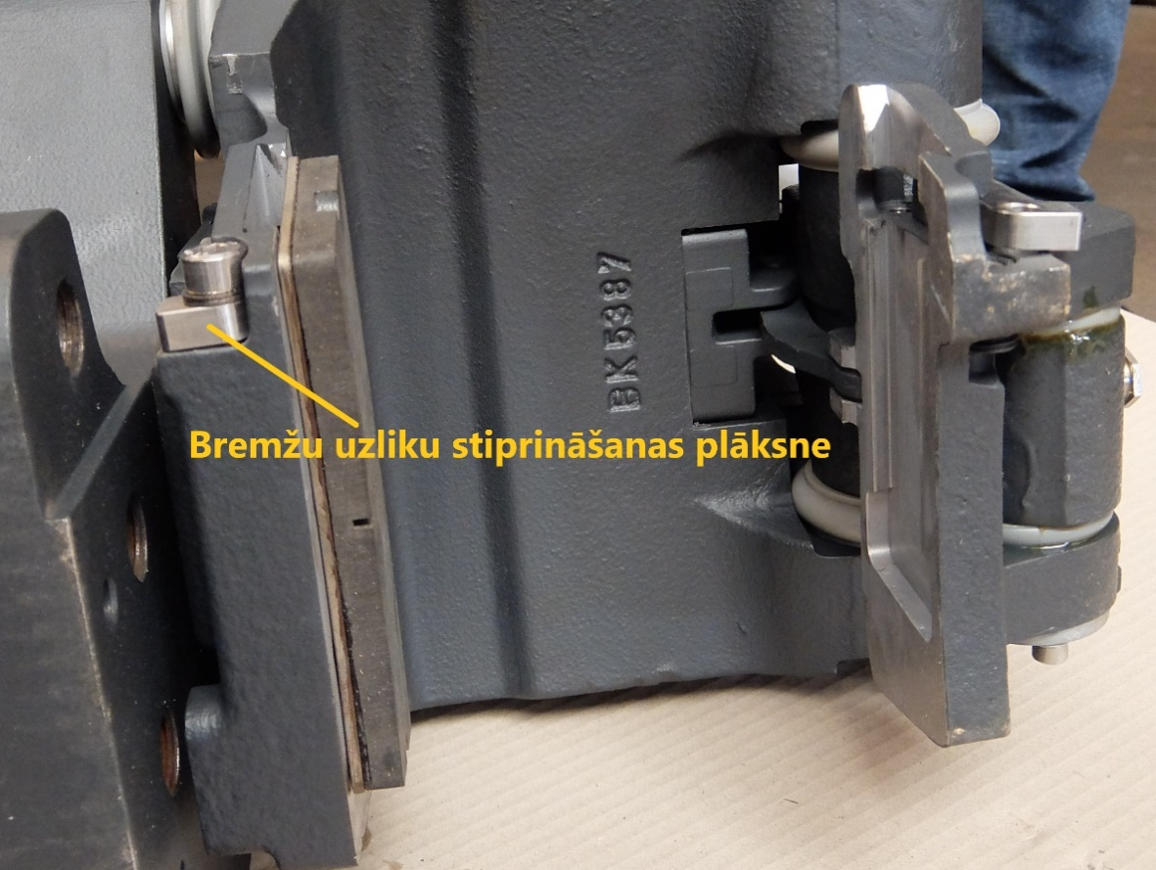

*Image No.1: Brake unit K.P.T.010 with modified fixation of brake linings in the holder (using a screwed-on plate).*

In order to ascertain that the said modification of the brake units is structurally suitable and valid for the actual conditions of operation and maintenance in Riga, it is necessary to carry out a test in which the bogies of one low-floor tram Škoda 15T are equipped with the said brake units and the said brake units are tested during day-to-day operation. Optimal duration of such an experiment – 2 years or 100 000 km mileage (responsibility of the customer).

The above test would require the purchase of four (4) new brake units for equipping one middle bogie of tram 15T RIGA – 2 pcs K.P.T.010/ 243 106 L (left) and 2 pcs K.P.T.010/ 243 106 P (right), the structural implementation of which would include the modification show in Image No.1 – brake linings are fixed in the seating of the brake lining holder by a screwed-on plate.